

**Orient OFS-24MS2 2 Ton**

**Rs. 90,999/-**

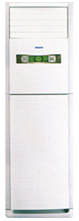

**Product Features**

* Independent Dehumidification
* Low Noise Air Flow System
* Easy Clean Panel
* Remote Control Pocket
* Three Minutes Protection

**Specification**

**Type** Wall Mounted Split AC

**Cooling (Btu/h)** 48000

**Voltage (V)** 220-240

**Power Input (W)** 3800

**EER (Btu/W-h-W/W)** 5.8-2.2